Lab Assignment-1

ECSE304L: Cloud Computing

**Name:** Tanvi Penumudy

**Enroll no**: E18CSE187

**Batch:** EB02

**Lab Activities:**

**Task 1:** Create AWS Free Tier Personal Account.

**Task 2:** Review the AWS Services and Account, Billing, Cost Dashboard, Cost Explorer, etc.

**Task 3:** Launch, Connect and Install EC2 IIS Webserver and Create a Static HTML Web Page.

**Implementation Screenshots:**

**Task 1**

* Created an Account on AWS

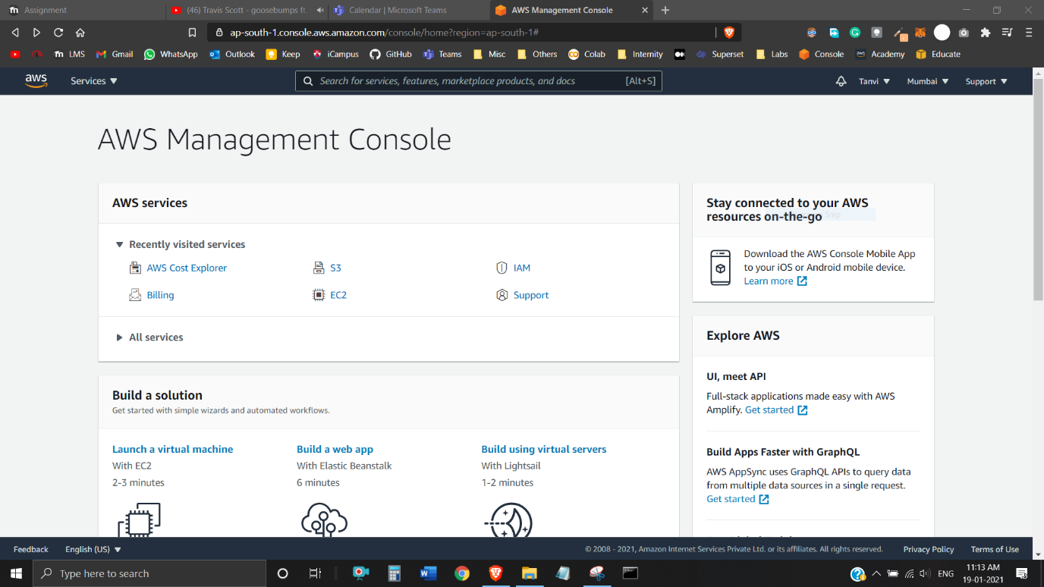

**Task 2 – Reviewed:**

* AWS Services
* Account
* Billing
* Cost Dashboard
* Cost Explorer

AWS Services:

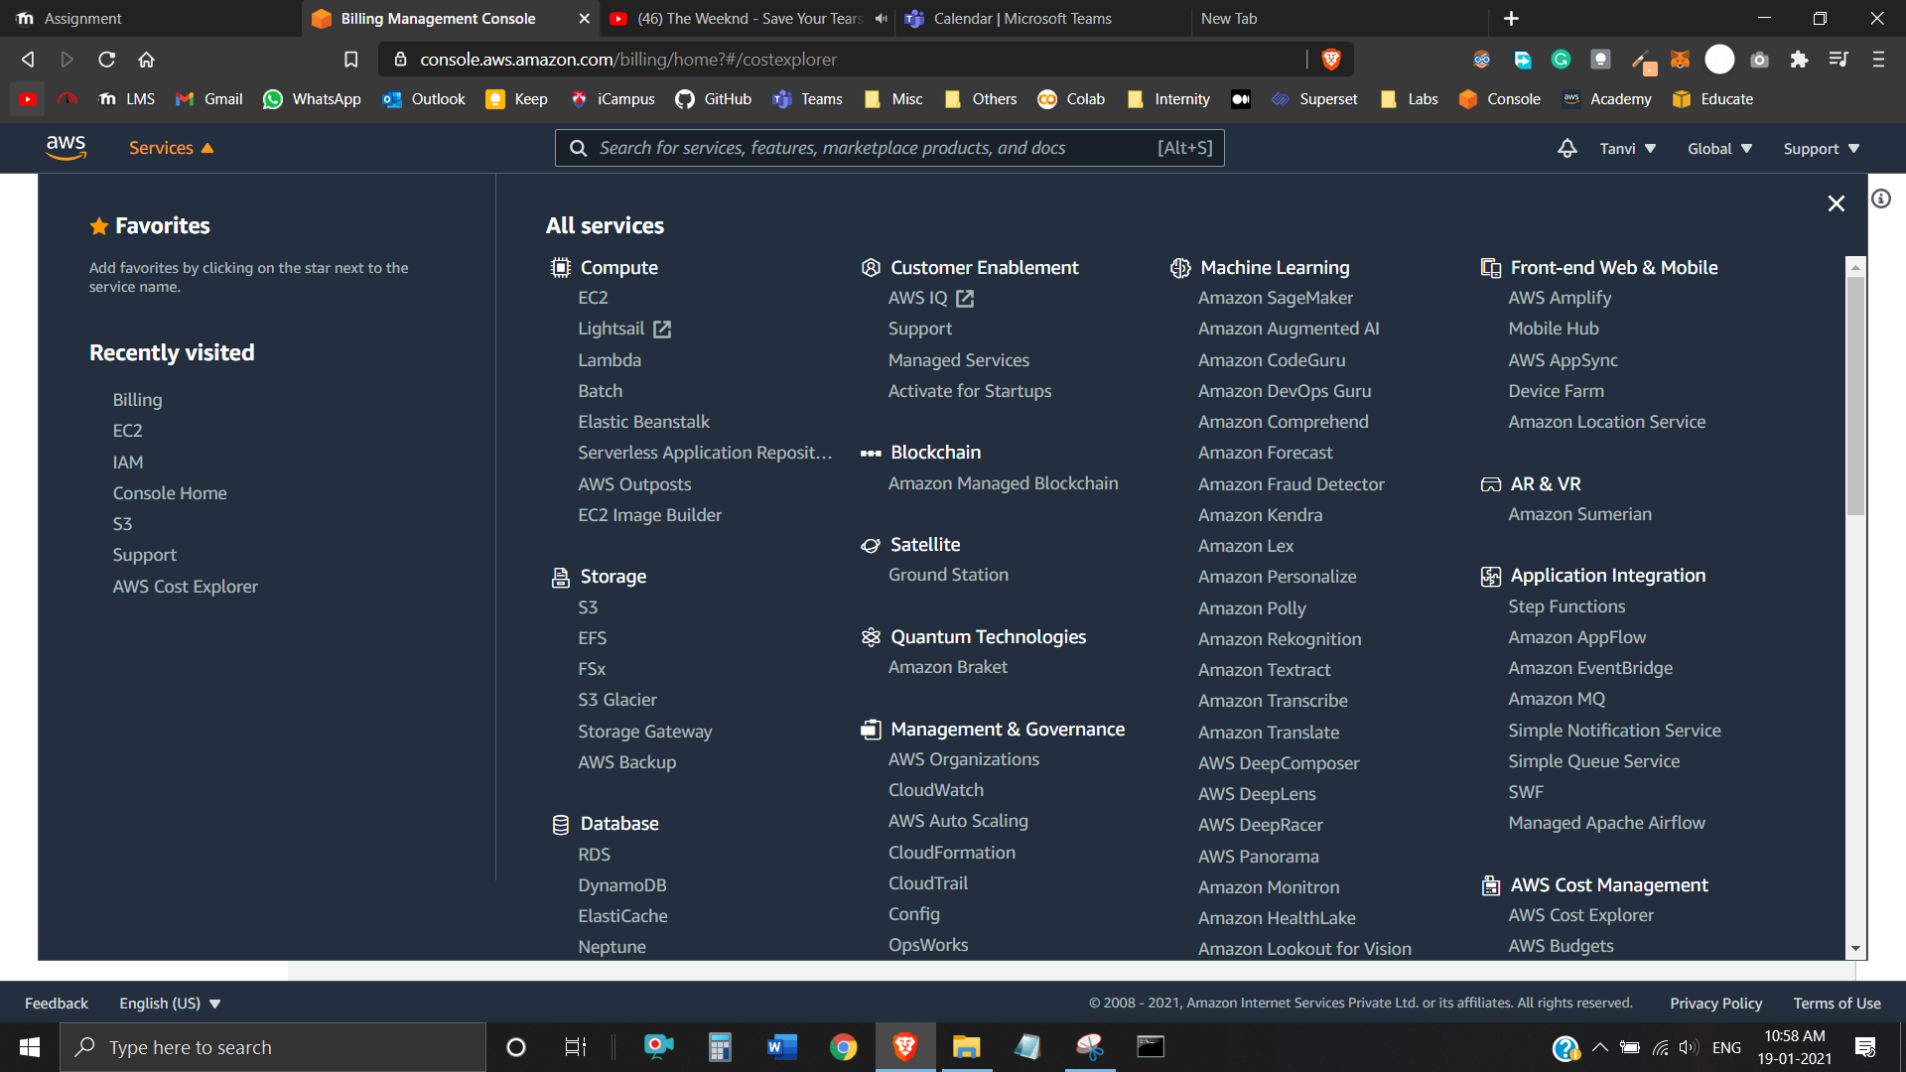

Account/Settings:

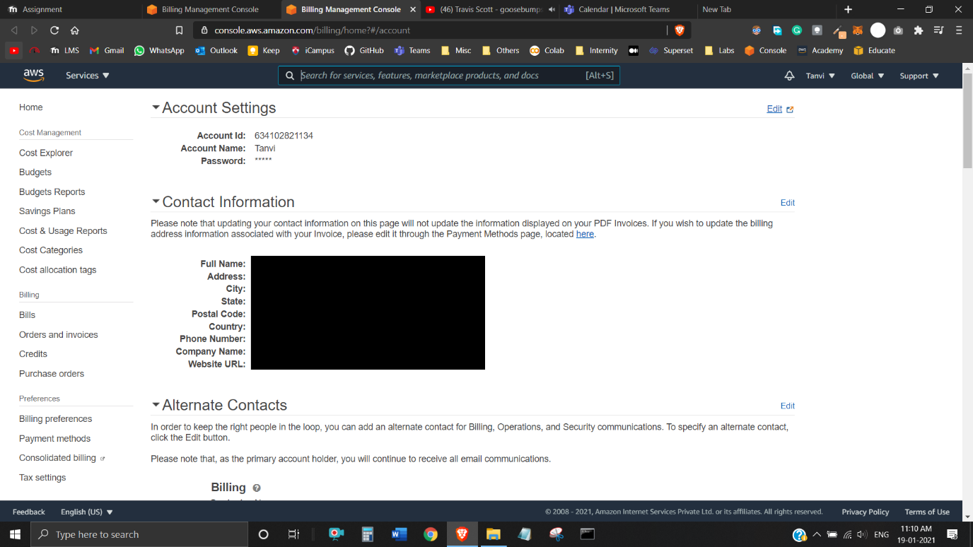

Billing/Cost Management Dashboard:

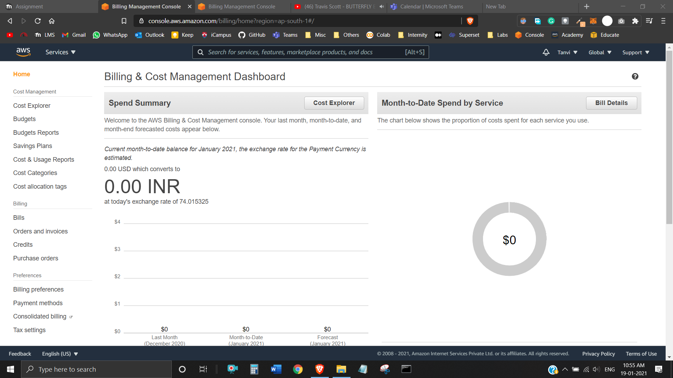

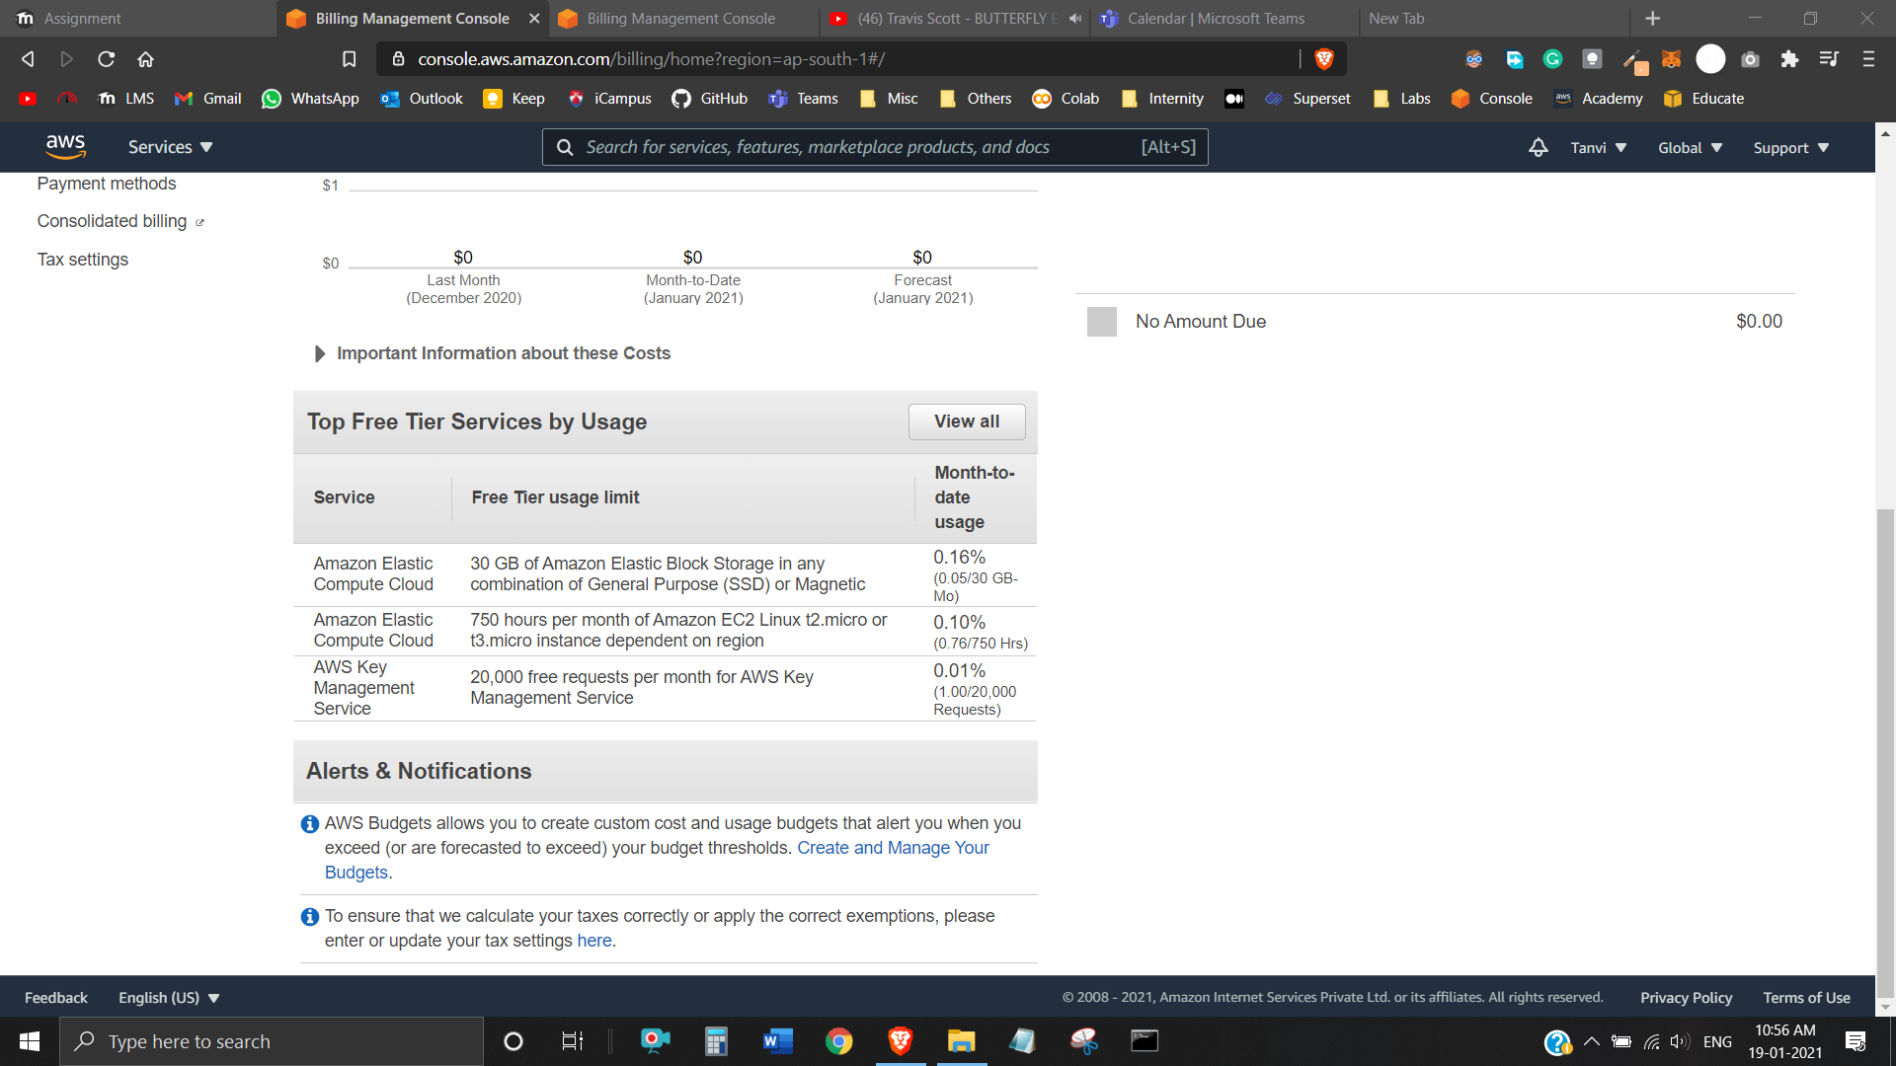

Cost Management:

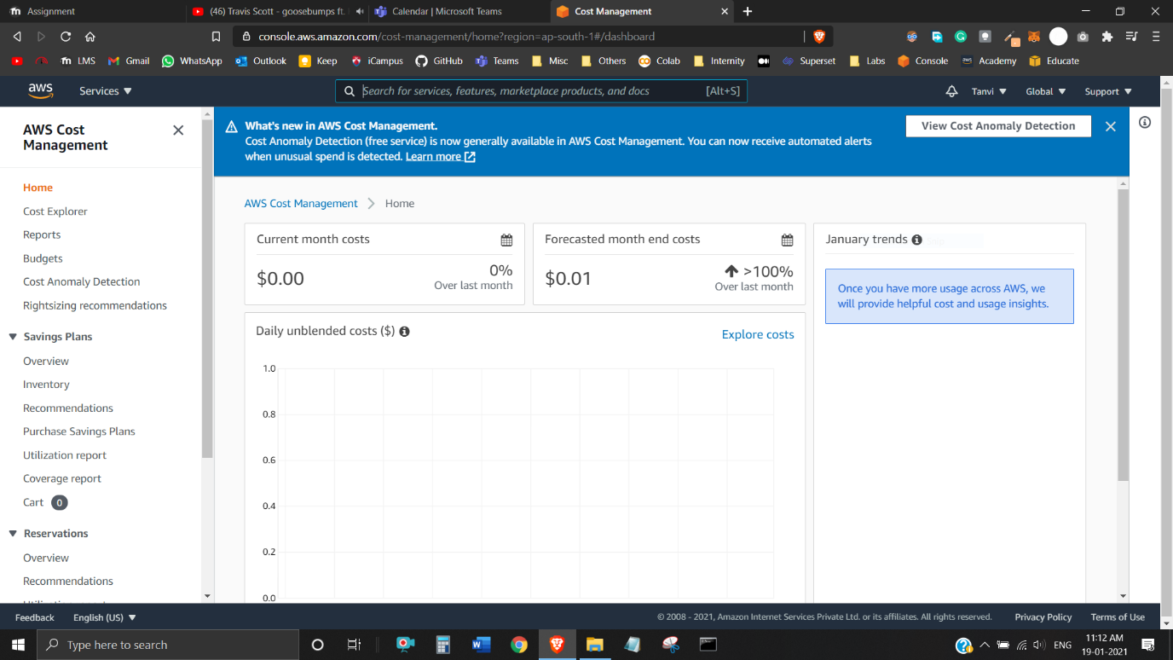

Cost Explorer:

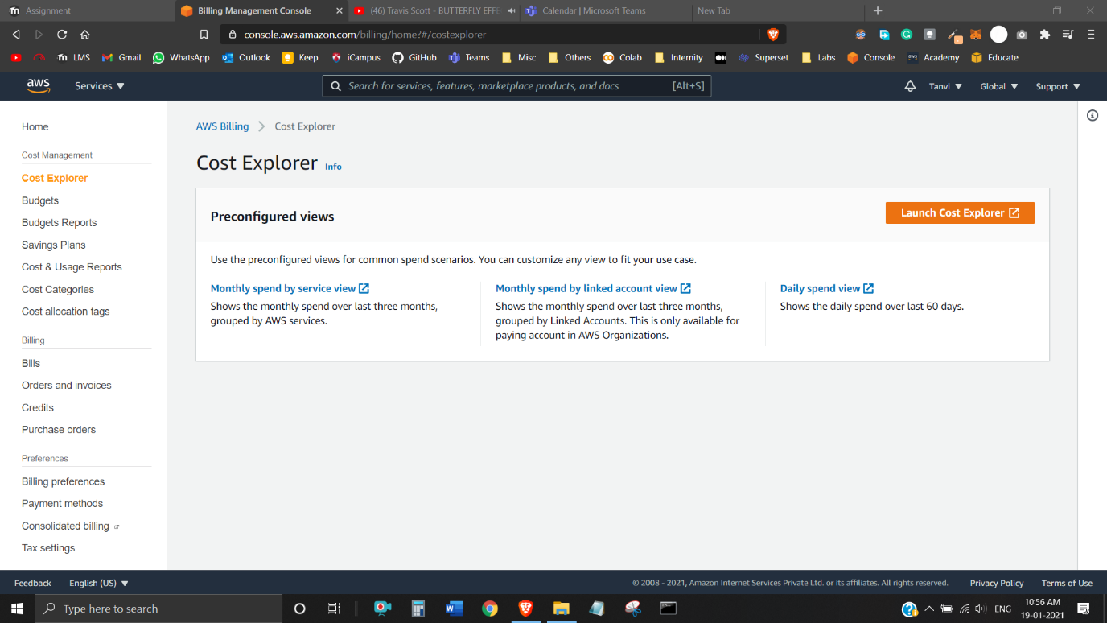

**Task 3**

* Launched, Connected and Installed EC2 IIS Webserver
* Created a Static HTML Web Page.

EC2 Instance Running:

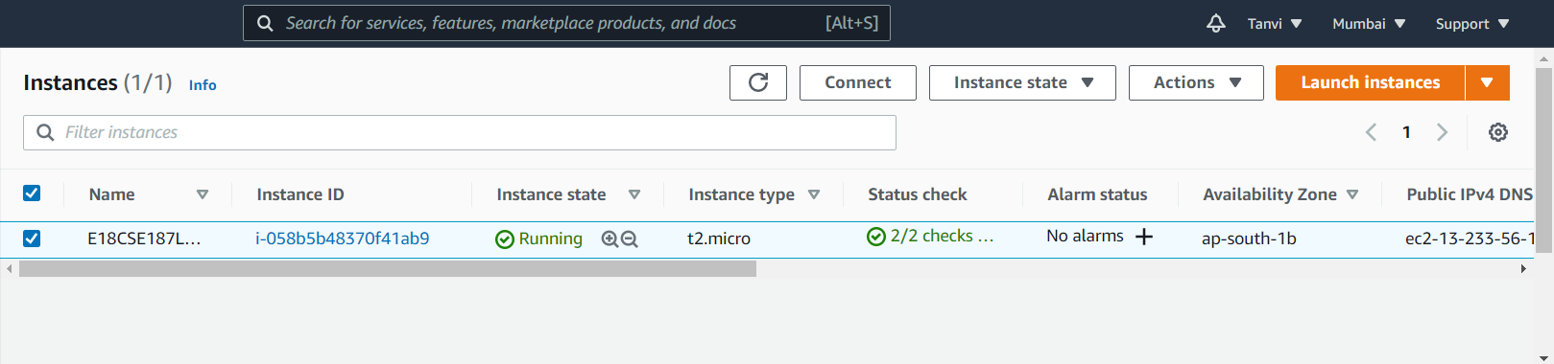

Set Security Group’s Inbound Rules (to RDP–default, SSH, HTTP & HTTPS):

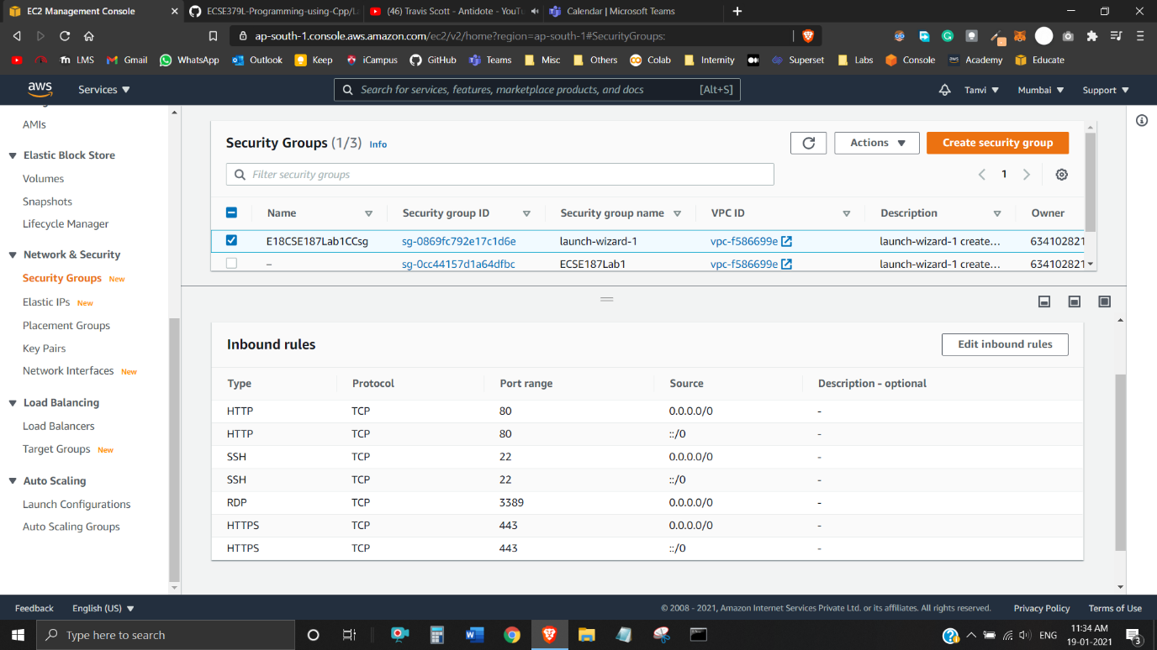

Connected to Instance:

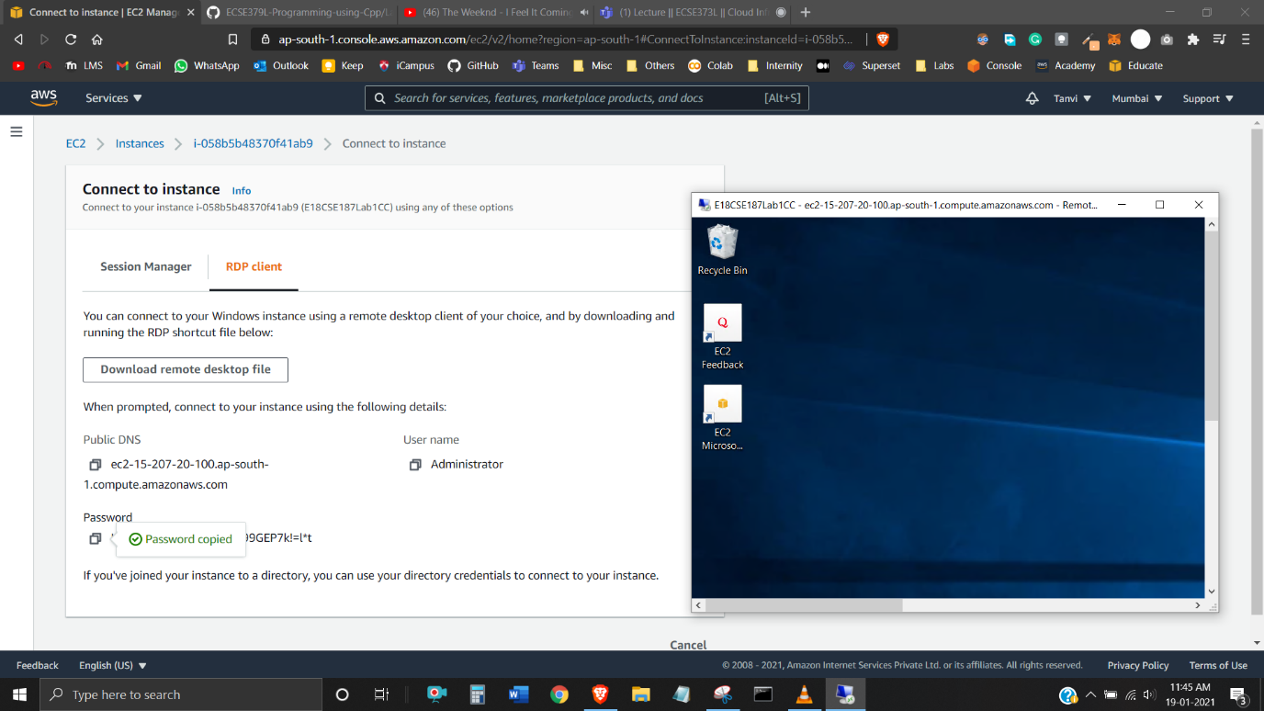

Installed IIS Web Server on AWS EC2 Instance (Windows Server):

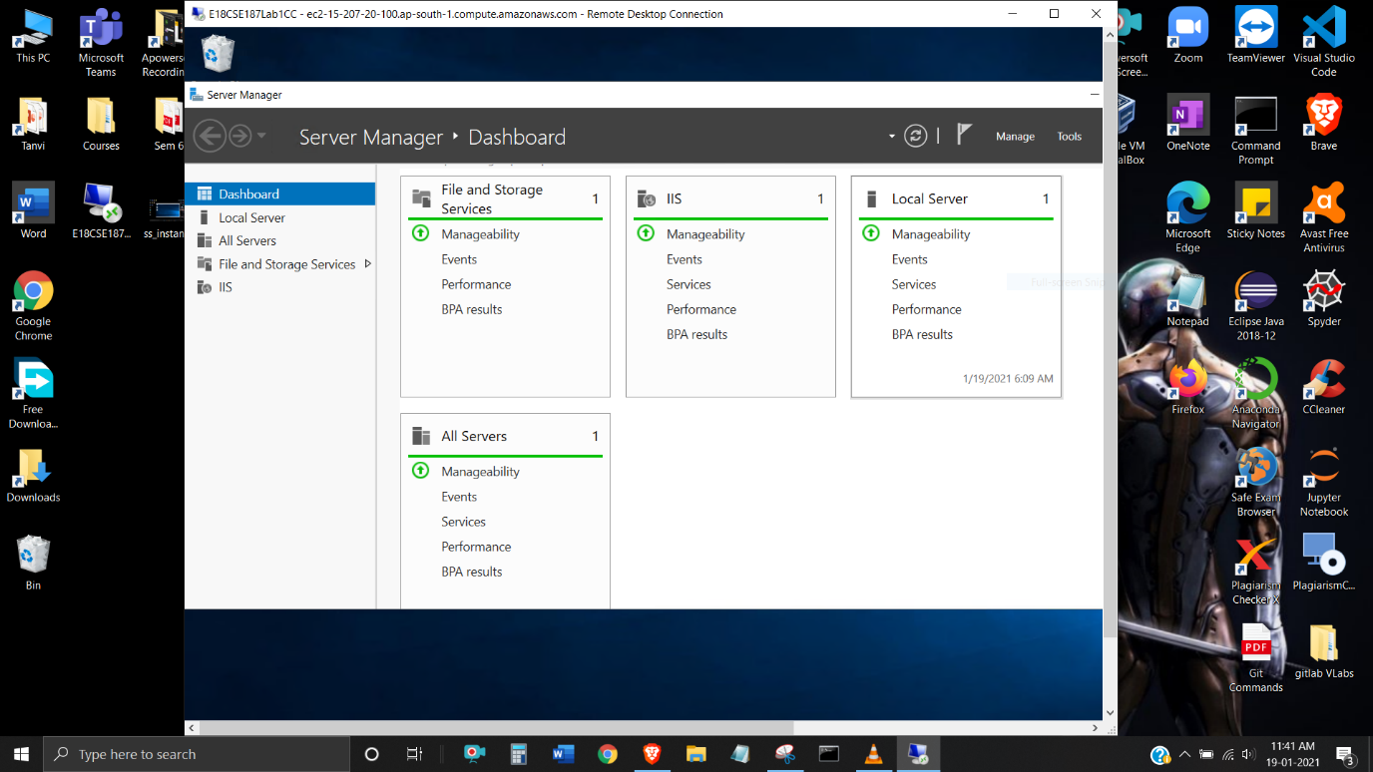

Created Demo HTML File:

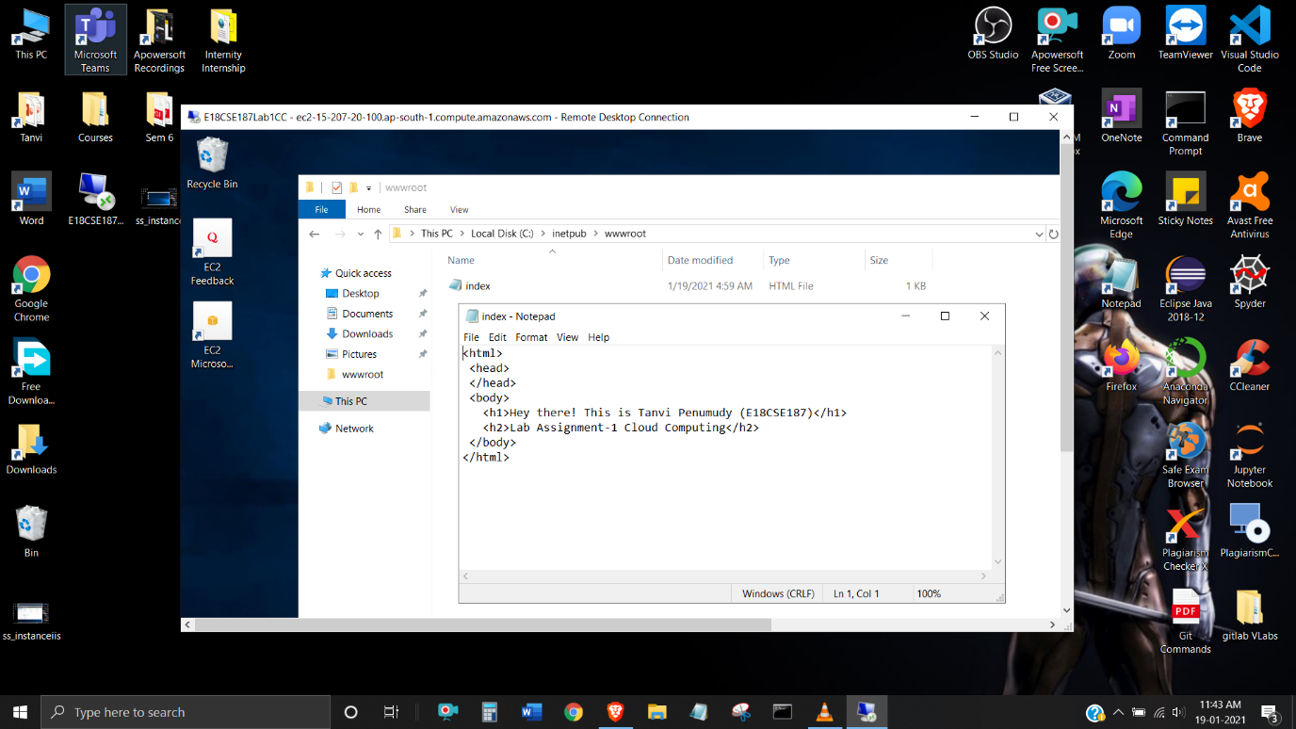

Running our Demo HTML Static Web Page on IP Address – 15.207.20.100

